Text Analysis

Statistical Exploration of the data sets :

The row data has been provided in three .csv format file. X_train, X_test and y_train. The following are the statistic on initial stage without any preprocessing.
Display information of: X_train
<class 'pandas.core.frame.DataFrame'>
RangeIndex: 84916 entries, 0 to 84915
Data columns (total 4 columns):
# Column Non-Null Count Dtype
--- ------ -------------- -----
0 designation 84916 non-null object
1 description 55116 non-null object
2 productid 84916 non-null int64
3 imageid 84916 non-null int64
dtypes: int64(2), object(2)
memory usage: 2.6+ MB
X_train contains the missing values in percentage which shows that Description is missing 35% of missing values.

designation 0.000000
description 0.350935
productid 0.000000
imageid 0.000000

Summary of X_train and X_test :

- The data sets X_train / X_test containing 4 columns and 84916 observations.
- y_train contains only the prdoduct type code.
- 35.1 % of the descriptions of X_train are missing
- 35.5 % of the descriptions of X_test are missing
- First look shows, that the texts in columns designation and description containing different languages, special characters and numbers.

The X_train consists of two columns names Designation and Description. It is observed that there 179 observations have identical designation and description. Some statistic below:

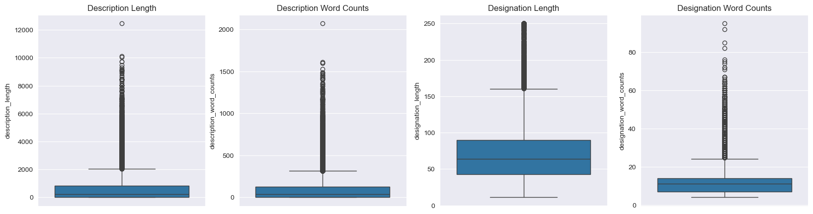

With decision to combine two columns (Description and Designation) by preventing duplication, the box plot gives the insight for the outliers.
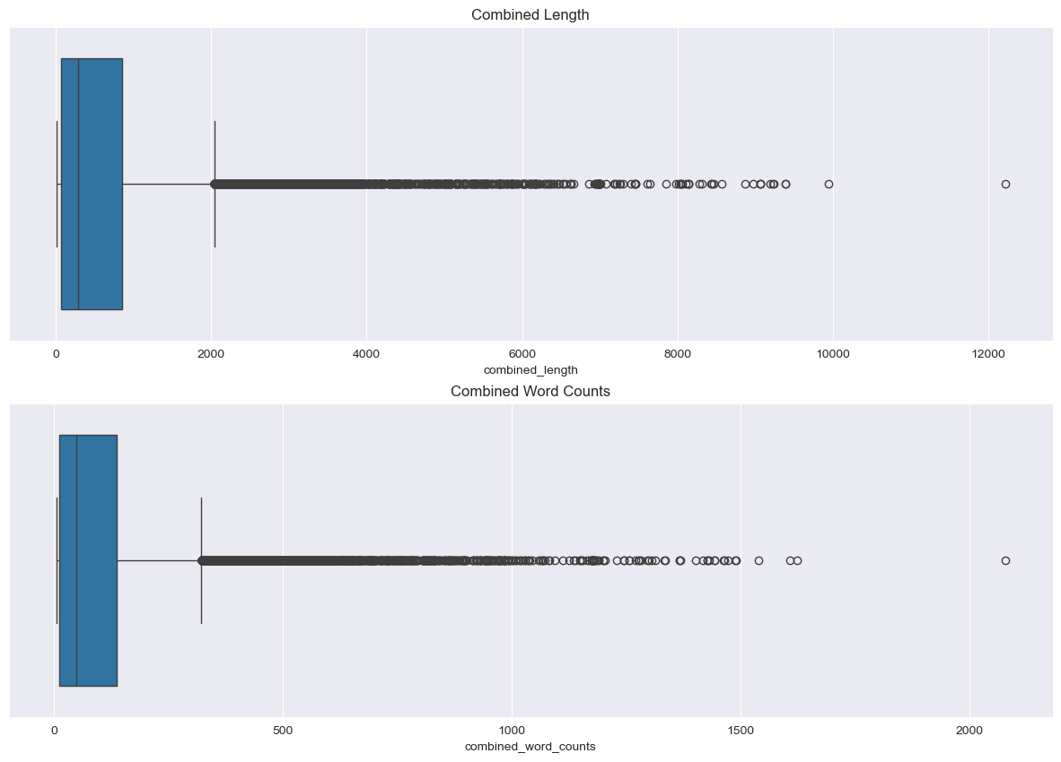

Y_train contains information about product type code. It also contains data with 84916 in row sets. The following graph shows the frequency of particular product type occurrence.

y_train has: prdtypecode 27
dtype: int64 with following distribution:
prdtypecode
2583 0.120225
1560 0.059741
1300 0.059412
2060 0.058799
2522 0.058752
1280 0.057351
2403 0.056220
2280 0.056055
1920 0.050674 ...
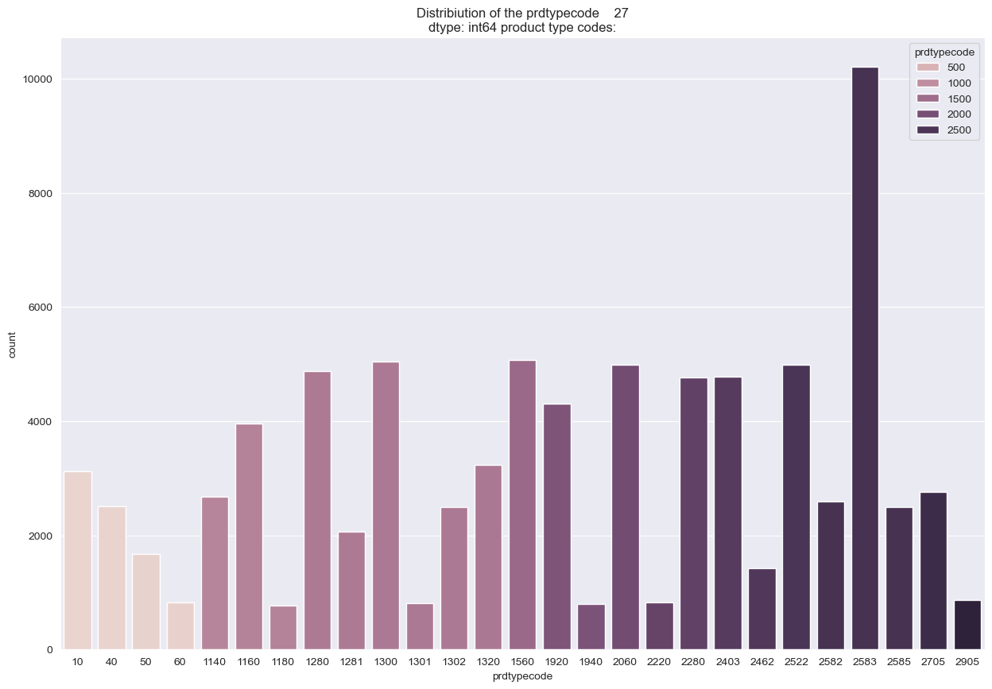

Summary – of target data :
- There are 27 different categories of product type codes.
- The categories are imbalanced.
- Most represented category is 2583 with 12 %.
Less represented category is 1180 with 0.9 %.

Missing value per Category :
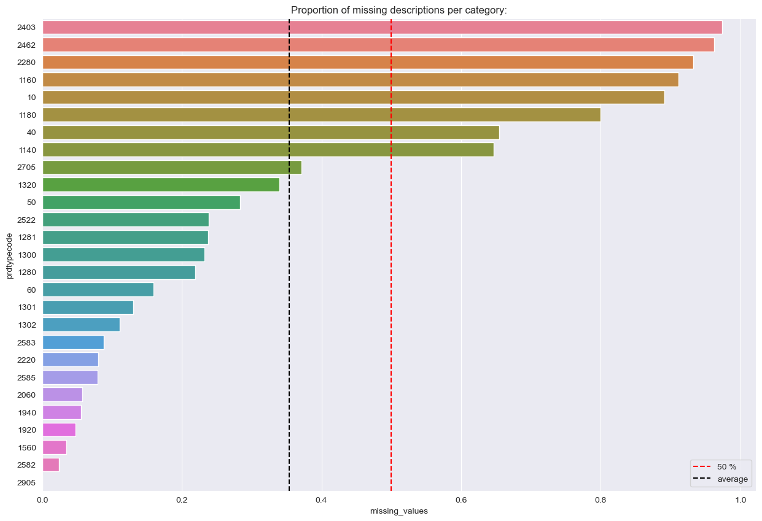

Summary – of target data :
- There are 27 different categories of product type codes.
- The categories are imbalanced.
- Most represented category is 2583 with 12 %.
- Less represented category is 1180 with 0.9 %.

It has been observed that a significant portion of the text is in HTML format. Efforts have been made to convert this HTML content into natural language text. However, some words still contain special characters or HTML artifacts, leading to a loss of meaning. Additional preprocessing steps were applied to transform these distorted words into meaningful ones. See the following example:
----------------------------------------------------------------------
{'MATELAS:Â·': 'MATELAS:·', '.Â·': '.·', 'Massante"Â·': 'Massante"·', 'cm.Â·': 'cm.·', 'Anti-moisissures.Â·': 'Anti-moisissures.·', 'couchage.Â·': 'couchage.·', 'électriquesCoutil:Â·': 'électriquesCoutil:·', '30Â°': '30°', '-Â·': '-·', 'matelas:Â·': 'matelas:·', 'System.Â·': 'System.·', 'dâ¿¿hygiène.Â·': 'dâ¿¿hygiène.·', 'Â·': '·', 'IndéformableÂ·': 'Indéformable·', 'journée.Â·': 'journée.·', 'crÃ¿me': 'crÿme', 'd\x92eau': "d'eau", 'l\x92été': "l'été", 'd\x92hiverner': "d'hiverner", 'l\x92arrivée': "l'arrivée", 'd’un': "d'un", 'd’ancrage': d’été': "d'été", 'l’ouvrage': "l'ouvrage", 'd’ouverture…)': "d'ouverture…)", 'd’art': "d'art", 'd’ouvrage.': "d'ouvrage.", 'l’irrésistible': "l'irrésistible"}

The analysis has been done to extract the frequency of the special character :

Count of special character : ,49
Frequency sum : ,114947

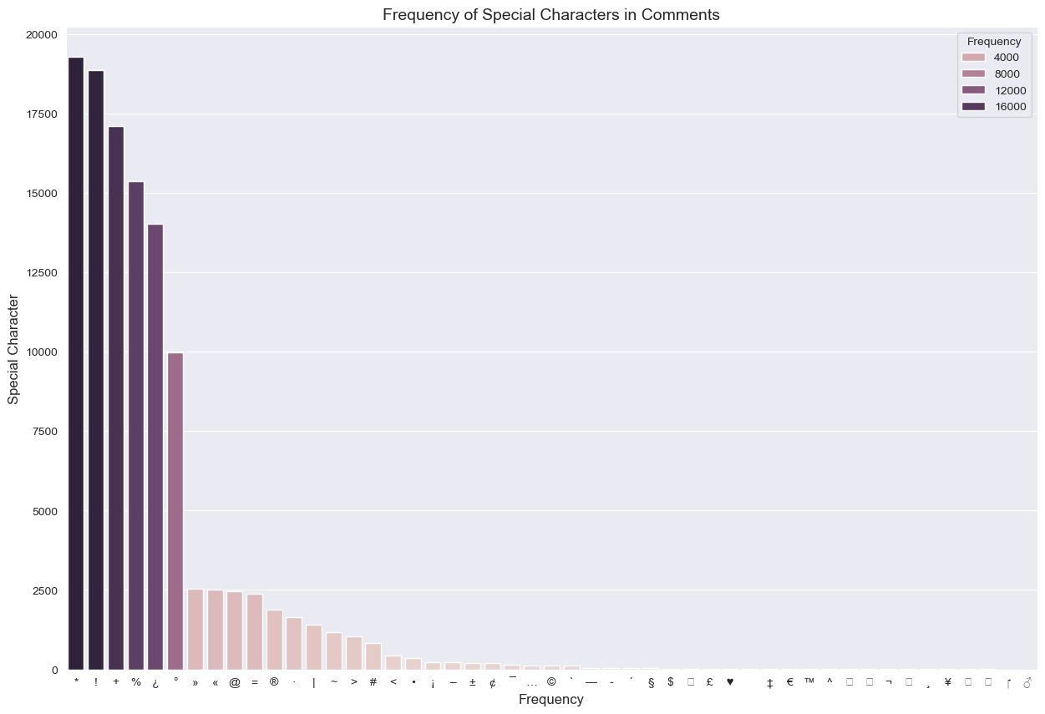

Conclusion : Should it be removed the unnecessary special character ? Would it be necessary for model training ?

Character, words and sentence analysis :

The goal of this step is to use boxplots to identify outliers within each category—characters, words, and sentences. These outliers will later inform strategies to mitigate class imbalance in the dataset. Below are some overall statistics derived from the initial analysis.

================================================================================
Total number of characters 47467530
--------------------------------------------------------------------------------
Total number of Words 7633697
--------------------------------------------------------------------------------
Total number of Sentences 371292
================================================================================

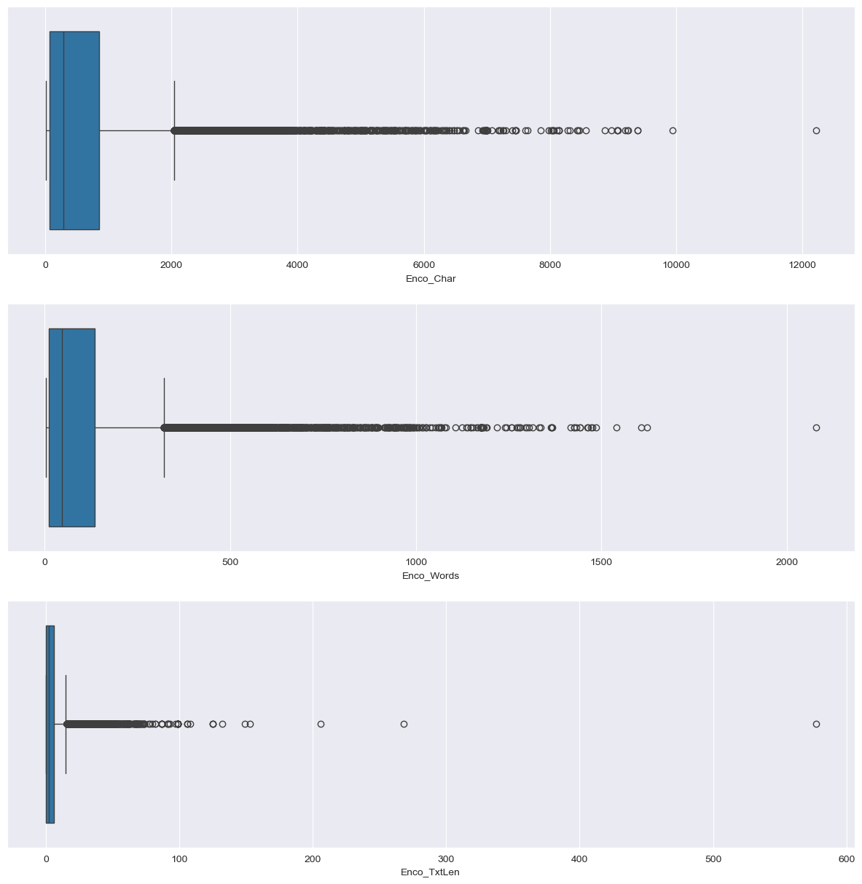

Language Frequency Analysis :
Top 10 most frequent languages:

 | Lang_Description | counts | normalized
0 | French (Français) | 60022 | 0.706840
1 | English | 15687 | 0.184736
2 | German (Deutsch) | 3403 | 0.040075
3 | Dutch (Nederlands) | 1458 | 0.017170
4 | Catalan (Català) | 1046 | 0.012318
5 | Italian (Italiano) | 762 | 0.008974
6 | Romanian (Română) | 435 | 0.005123
7 | Spanish (Español) | 377 | 0.004440
8 | Portuguese (Português) | 345 | 0.004063
9 | Indonesian (Bahasa Indonesia) | 213 | 0.002508

Top 10 less frequent languages:

 | Lang_Description | counts | normalized
21 | Croatian (Hrvatski) | 41 | 0.000483
22 | Slovenian (Slovenščina) | 38 | 0.000448
23 | Vietnamese (Tiếng Việt) | 35 | 0.000412
24 | Turkish (Türkçe) | 28 | 0.000330
25 | Hungarian (Magyar) | 15 | 0.000177
26 | Lithuanian (Lietuvių) | 15 | 0.000177
27 | Albanian (Shqip) | 7 | 0.000082
28 | Czech (Čeština) | 7 | 0.000082
29 | Slovak (Slovenčina) | 6 | 0.000071
30 | Latvian (Latviešu) | 5 | 0.000059

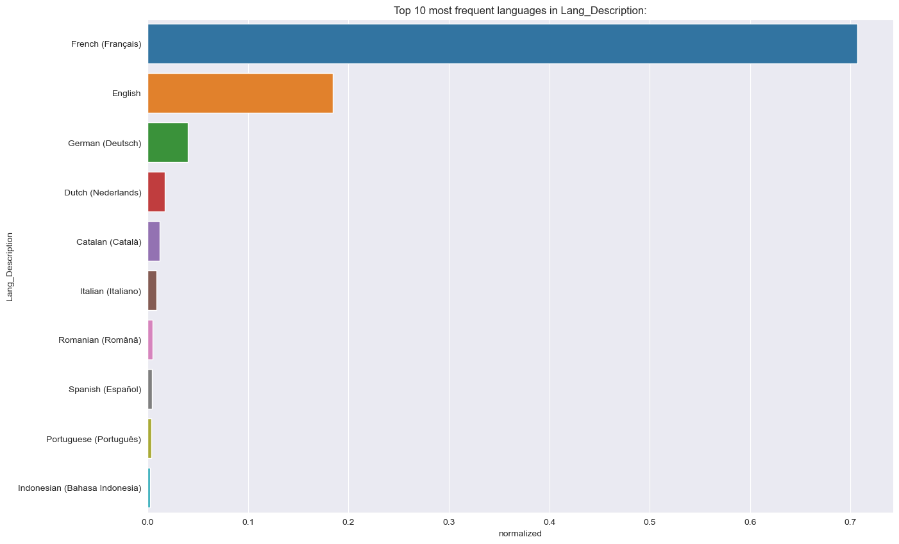

Data after LLM :
As observed above, most of the text in the dataset is in French, English, and German. To streamline data preprocessing, all text in the DataFrame will be translated into English using a local LLM.
An open-source model, Ollama, is used for this purpose. However, due to the large size of the dataset, the translation process is expected to be computationally expensive.
For the initial experiment, 2,000 rows from the original dataset were extracted and translated using the LLM. All previously defined metrics were applied to this subset to obtain an initial evaluation of the translation output.

If the LLM remove some special character ? Special Character Analysis :

Data frame before LLM :

---------------------------------------------------------------------------------------------
Count of special character : ,27
Frequency sum : ,2787
['!' '¿' '+' '%' '*' '°' '·' '«' '»' '=' '@' '®' '>' '|' '#' '~' '•' '–'
'<' '¢' '¡' '¯' '±' '…' '`' '§' '$']
---------------------------------------------------------------------------------------------

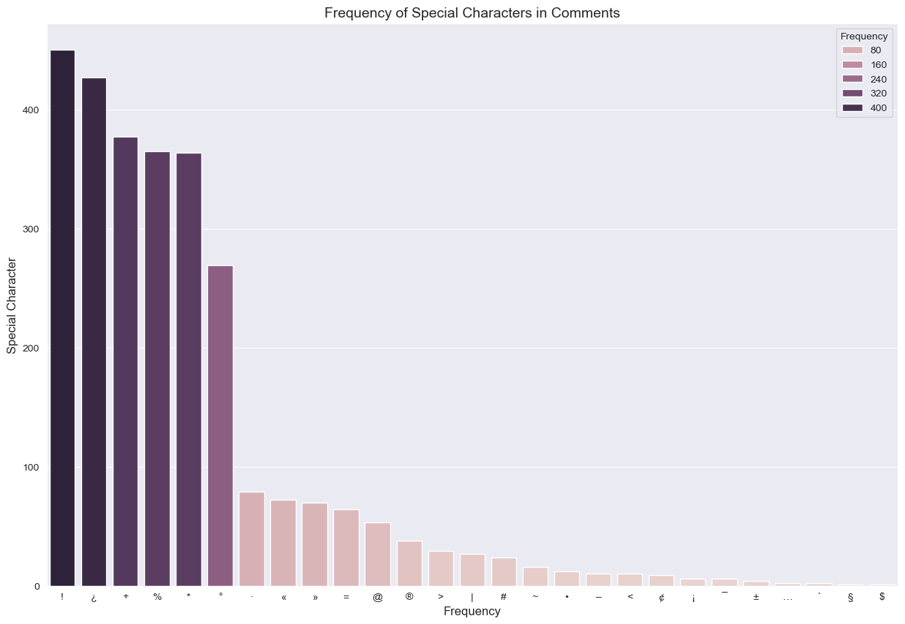

---------------------------------------------------------------------------------------------
Count of special character : ,23 Frequency sum : ,1998
['!' '*' '+' '%' '°' '=' '@' '#' '®' '>' '|' '~' '–' '¿' '•' '»' '«' '±' '·' '©' '`' '$' '<']
---------------------------------------------------------------------------------------------
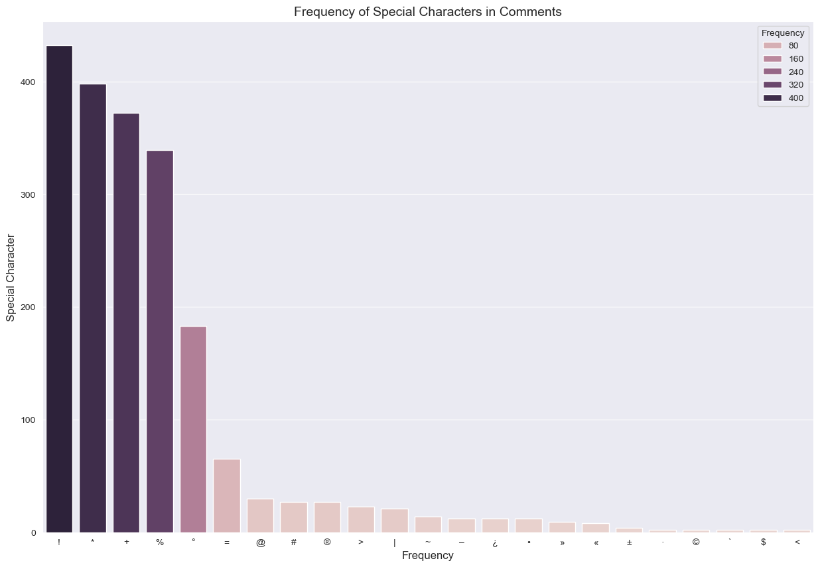

Language Analysis :
Before LLM : 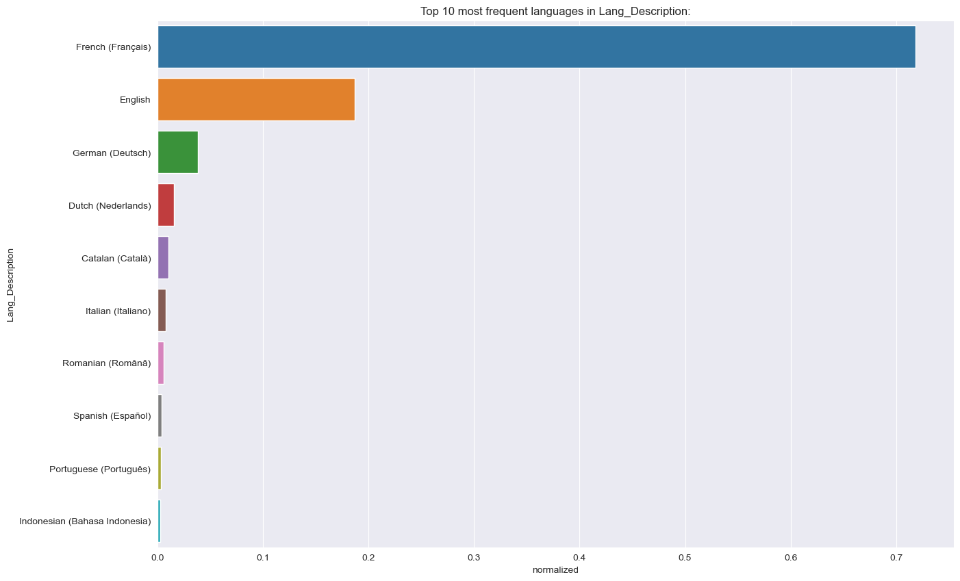

After translation to English :
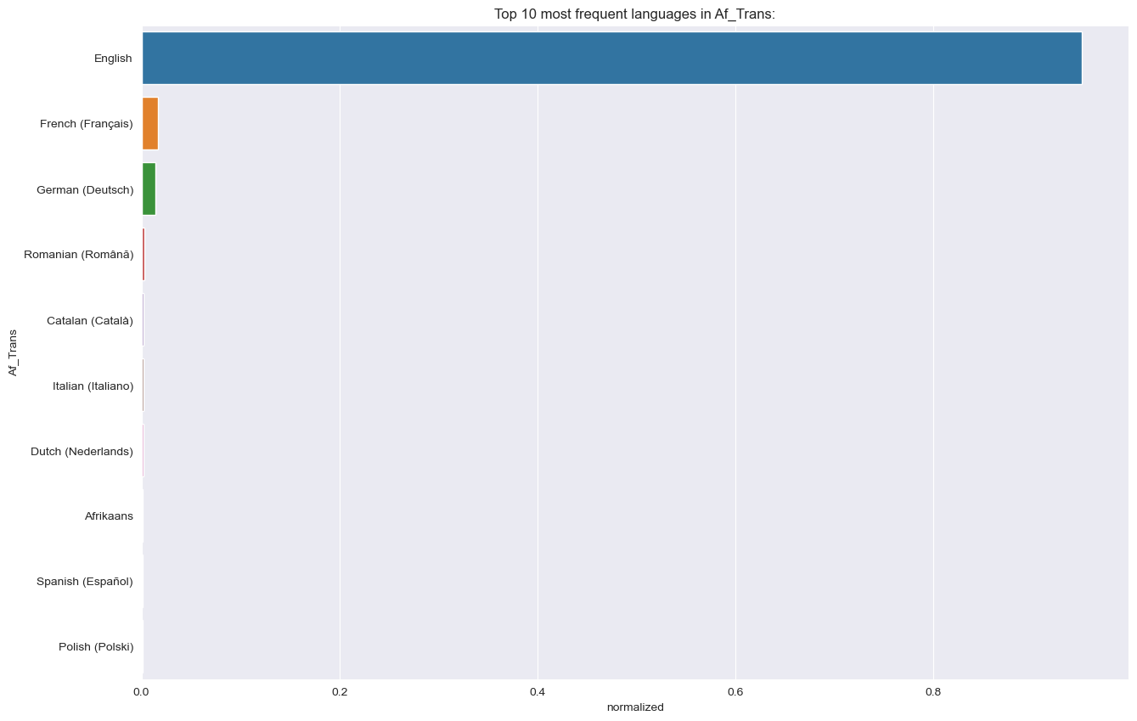

Character, words and sentence analysis :
 | Before | After
Character | 1106088 | 963836
Words | 177712 | 157367
Sentences | 8548 | 8623

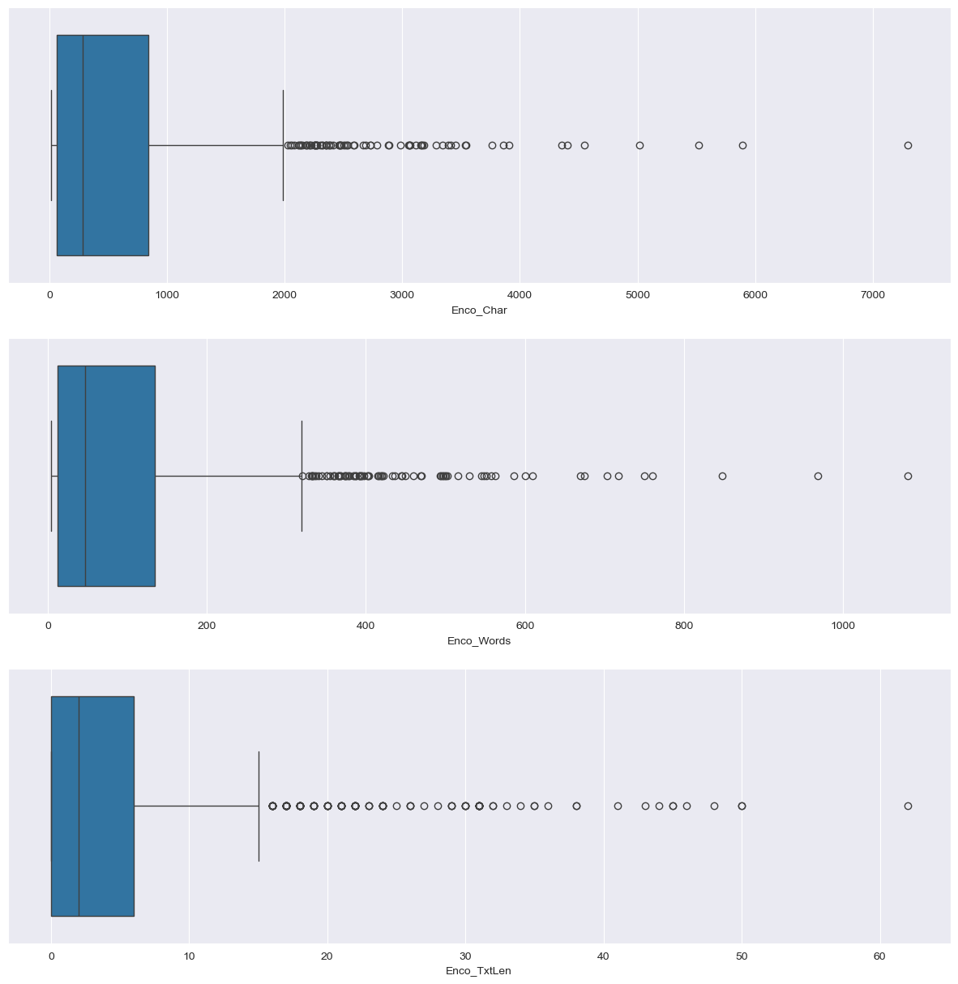
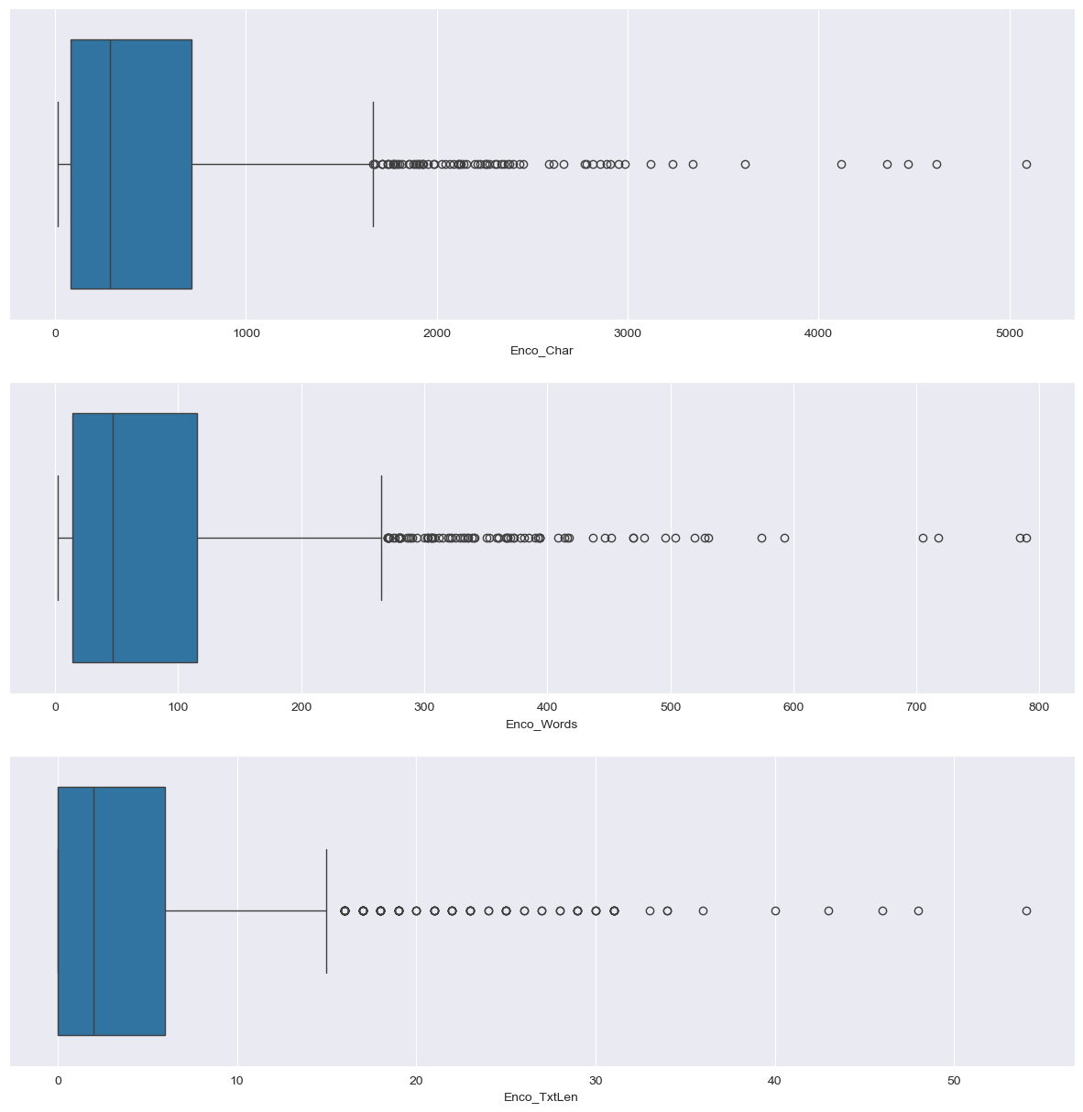








Observation :

Even after applying the LLM, some parts of the text remain untranslated. Upon reviewing the dataset, this appears to be an issue with the language detection library. Consider investigating further using the spaCy library.

The LLM removed certain special characters and reduced the frequency of others. This might be due to translation effects, particularly if those characters represent accents or diacritics.

The overall frequency of words, characters, and sentences has decreased after using the LLM.

The LLM is computationally expensive for translation—it took approximately 3 hours to process just 2,000 rows from a single column.

A hybrid approach might be more efficient: using Google Translate or DeepL API for translation and reserving the LLM for tasks like summarization or text enrichment. One could also compare the effectiveness of LLM translation versus API-based translation to evaluate quality and performance.

